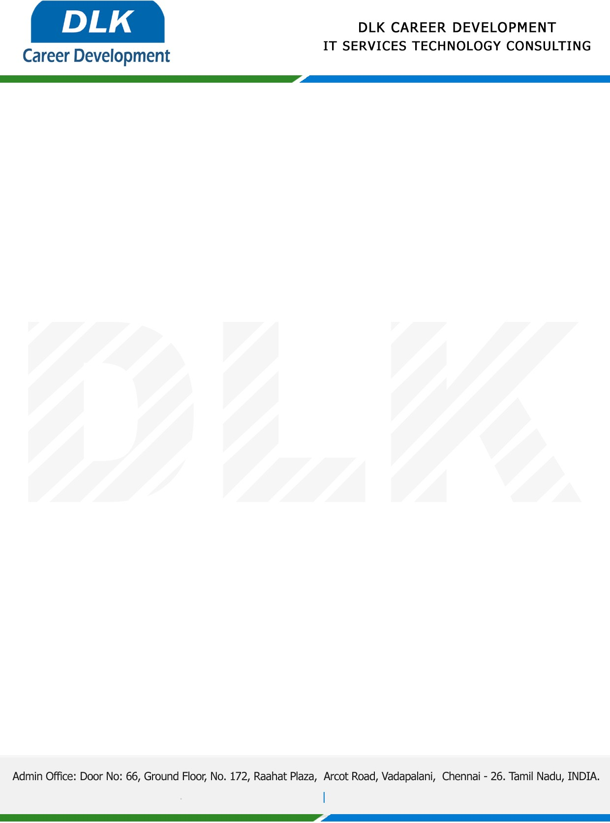

Date: 09/ January / 2023

**To**

Department of BE ([Computer Science Engineering),](https://www.cseindia.org/)

Head of Department,

Velammal Engineering College, Chennai - 600066.

**Sub: Letter of Internship Acceptance**

This is to certify that **MS VIBHUSHA S (REG NO: 113220031163)** third year student of has accepted her Internship Work duration from **10th January 2023** to **27th January 2023** under the domain”**Data Mining”.** During the internship, all information and data collected from your should be kept confidential.

We appreciate your interest in **DLK CAREER DEVELOPMENT**

